Report about best devices in PC, best operating system and suitable programming languages.
System Name: Medical Appointment Booking System
- Best Devices
Phones: To Be Contacted by patients to schedule Appointments on certain days
Computers: To schedule The Appointments and view the appointments
Servers: To Store The Appointments Data, Doctors Data, Patients Data

- Best Operating System
Windows: An easy to use operating system because it is simple and has good compatibility with .NET Framework.
Linux: It is good with servers, offers good security Features

- Suitable Programming Languages
C#(.NET Framework / .NET Framework Core): works well with windows operating system and it’s flexibility is high and has good security.
SQL server: To implement the database and insert the data of the patients, doctors, Appointments.

Design of an integrated system (Class diagram)

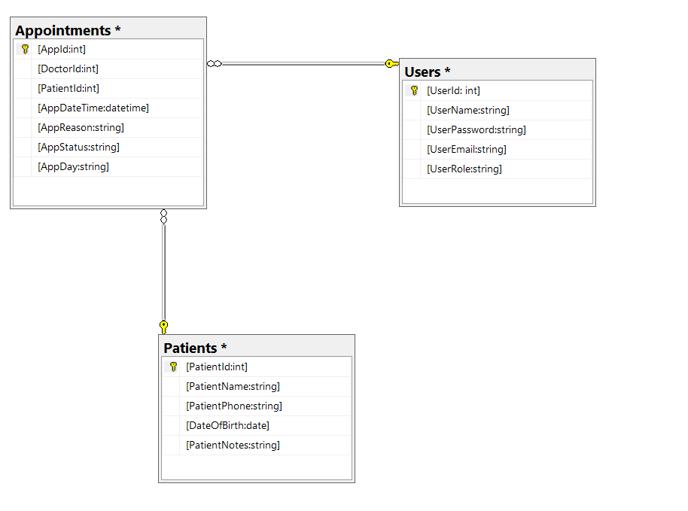

Testing
Test case ID | Test case description | Test Steps | Test Data | Expected Result | Actual Result | Pass/Fail
1 | Testing Login Functionality(valid username valid password as receptionist) | Get Username  Get Password  Click login | Username: Youssef Elsayed  Password: Joo123 | Login to Appointment scheduling page | Exception Didn’t find user | Fail
2 | Testing Login Functionality(valid username valid password as receptionist) | Get Username  Get Password  Click login | Username: Youssef Elsayed  Password: Joo123 | Login to Appointment scheduling page | Login to Appointment scheduling page | Pass
3 | Testing Login Functionality(valid username valid password as doctor) | Get Username  Get Password  Click login | Username: Hager Elsayed  Password: Gory321 | Login To Doctor Page | Login To Doctor Page | Pass
4 | Testing Login Functionality(invalid username valid password) | Get Username  Get Password  Click login | Username: Youssef ELsayed  Password: Joo123 | Error message Invalid username or password | Error message Invalid username or password | Pass
5 | Testing Login Functionality(valid username invalid password) | Get Username  Get Password  Click login | Username: Youssef Elsayed  Password: Joo321 | Error message Invalid username or password | Error message Invalid username or password | Pass
6 | Testing Login Functionality(blank username blank password) | Get Username  Get Password  Click login | Username:-  Password:- | Error Message please Enter Username Or password | Error Message please Enter Username Or password | Pass

